**P6/5 Term 2**

Things to remember:

* Please bring a suitable spare pair of shoes for inside the school and PE.

**Dates for your Diary:**

* Tuesday 22nd November – Sports Leader Visit
* Friday 25th November – Curriculum Cafe
* Friday 2nd December – Christmas Fayre
* Thursday 8th December – Santa Fun Run
* Tuesday 13th December – Christmas Panto
* Wednesday 14th December – Christmas Lunch
* Friday 23rd December – Break up for Christmas Holidays
* Monday 9th January – Back to school



Children have taken on a variety of classroom jobs to encourage them to take responsibility for looking after our classroom community. These will rotate weekly, and include roles such as resource monitor, line leader, librarian and milk monitor.

Children earn dojo points throughout the week, for themselves and for their table. At the end of each week the table and pupil who has the most dojos win a prize.

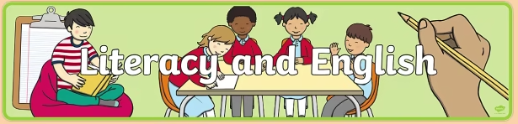

In writing, this term we will be learning how to write a persuasive piece, starting with an exposition, a one sided argument, and then moving onto a discussion, a two-sided argument. The children have opportunities for free writing every Friday, they can use this time to write about anything they want to.

In our reading lessons, we will be continuing to practise our four reciprocal reading strategies; predicting, clarifying, questioning and summarising. We will be implementing these strategies when reading a selection of fiction and non-fiction texts.

Spelling words are given out every week. Children will practise their words using active games and digital technology.



Our topic this term will be the Titanic. We will learn about the history of the making of the Titanic. We will have a science and engineering focus on our learning to examine why the Titanic sank and to consider factors related to water, ice and buoyancy. We will also conduct historic research to explore Scotland’s own famous shipbuilding industry.



Our P5’s have been working hard on their Discover badge and will continue to work towards this, learning about different STEM jobs and what qualities they need for these. Our P6’s have been working hard towards their Inspire badge, looking at what inspires them and how they can inspire and encourage the other children in our school to get involved in STEM.

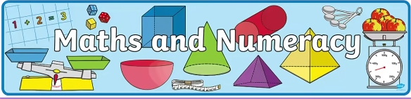

In Numeracy this term, we will practise our estimation skills and rounding of numbers to the nearest 10, 100 and 1000. We will be recapping our knowledge of addition and subtraction numbers up to 1 million using mental and written strategies.

For our Beyond Number topic, this term we will be looking at angles. We are identifying right, acute, obtuse and reflex angles in 2d shape, using protractors to measure and draw angles. We will also be recapping our knowledge of the compass points and can use these to give directions.



In PE this term, we will be learning about basketball. We will focus on our dribbling, ball handling and shooting skills. With Mrs Jordan, the class will be focusing on handball. Children are to wear school polo shirts/top with navy/black joggers, shorts or leggings. Please ensure the children have gym shoes to wear inside the school.

Each month we will be learning about a different Wellbeing Indicator. In November we will be focusing Achieving, looking at key qualities and attributes in a variety of situations. In December, we will be focusing on understanding that people have different food nutritional needs throughout their lives.



During this term will be both reinforcing and building on our French and Spanish language skills. We will continue to practise important vocabulary through daily greetings as well as weekly focus sessions to introduce new topics and phrases. This term we will be covering several mini topics including personal information, numbers and letters, talking about our families and classroom items. We will also explore French and Spanish traditions and celebrations. We will use a variety of games, songs and activities to explore fun ways to learn and practise our pronunciation and to reinforce new phrases and vocabulary.

Sale prices good through 11/17/03

Store Hours:

10:00 A.M. – 5:00 P.M. (M thru F)

9:00 A.M. – 6:00 P.M. (Sat. & Sun.)

**Daniel Escapa**  
Fine Art

98765 Main Street

Savannah, GA 98031

Located in Harrington across from Memorial Park