**Some things to remember:**

* PE Days – Tuesday and Thursday
* Monday, Tuesday, Thursday PM and Friday are with Miss Cairney
* Wednesday and Thursday AM are with Mrs McAnaw

**P5/4 Term 2**

**Dates for your Diary:**

* Friday 25th November – Curriculum Café
* Friday 2nd December – Christmas Fayre
* Tuesday 13th December – Pantomime
* Friday 23rd December – Last day of term
* Monday 9th January – Return to school

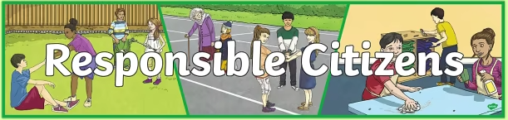

Children are continuing to take on a variety of classroom jobs to encourage them to take responsibility for looking after our classroom community. We have added some new roles throughout term 1 that rotate weekly, including ICT Monitors and Cloakroom Monitors.

Children earn stars in class for following school rules and showing our school values. For every 10 stars they earn, they can choose a prize.

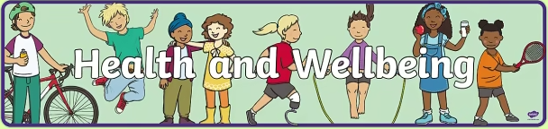

In PE this term we will begin with Gymnastics. We are continuing to practice our team-working skills and ball-control skills through Handball. Later in the term, we will move on to Scottish Dance.

We will continue to explore our Wellbeing Indicators. During these lessons we will be learning what it means to achieve and celebrating our successes.

We are continually developing our understanding of our emotions and how to manage these through the Zones of Regulation.

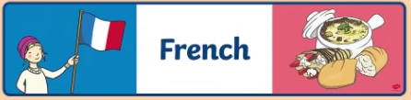

We will be learning the colours and numbers in French, aswell as using everyday classroom language.

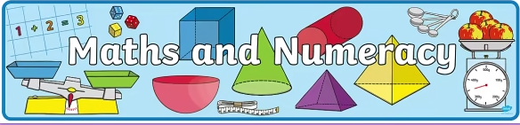

This term we will be working on different addition and subtraction strategies, including both written and mental strategies.

In beyond number this term, we will be learning all about shape. We will consolidate our knowledge of 2D and 3D shapes and their properties. We will also learn about tessellation and what shapes we can tile.

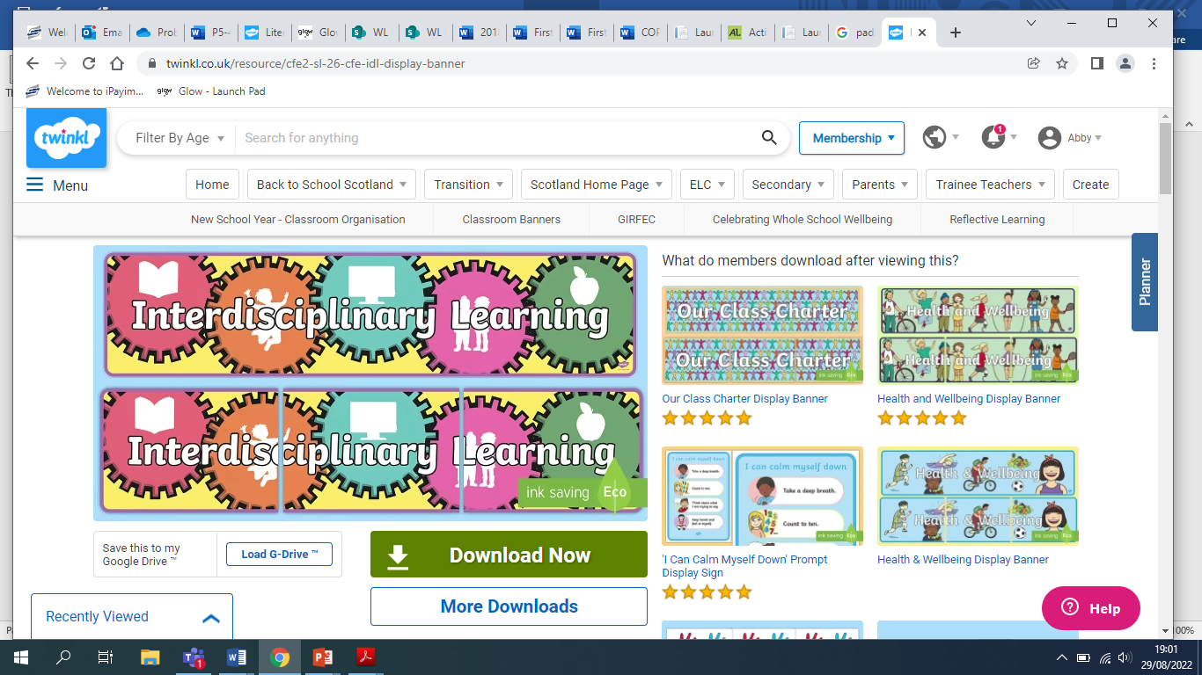

This term, we are covering the ‘The Rainforest’ as our IDL topic. We will focus our learning on the plants and animals found in each layer of the rainforest, as well as the climate and weather. We will also learn about deforestation and its impacts.

Later in the term, we will be learning about Jewish traditions at Hanukkah and comparing similarities and differences between this and Christian traditions at Christmas.

**Homework**

Reading books will be given out every Friday for children to practice reading at home. Big Bedtime Reads have also been sent home, and should be returned when finished reading so we can swap these for new ones.

Spelling words will also be given home in homework diaries each Friday. Children can use different strategies to practice these at home.

Common words for some pupils will be given each week.

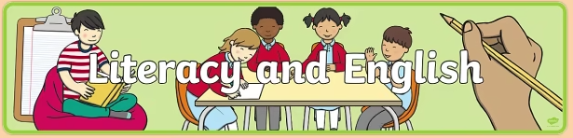

In writing, this term we will be focusing on persuasive writing by learning how to write an exposition.

In our reading lessons this term we will be focusing on our ‘Ready to Read’ strategies, which will help pupils to develop their understanding of the texts we are reading. Within our reading lessons we will also look at grammar and punctuation.

Spelling words are given out weekly. Children will practise their spelling words in a variety of different ways each morning, including online by logging into Glow, alongside recapping their common words.

Sale prices good through 11/17/03

Store Hours:

10:00 A.M. – 5:00 P.M. (M thru F)

9:00 A.M. – 6:00 P.M. (Sat. & Sun.)

**Daniel Escapa**  
Fine Art

98765 Main Street

Savannah, GA 98031

Located in Harrington across from Memorial Park